Important Questions
Module 1
- Describe sigmoid activation functions.
- Write the gradient descent algorithm.
- Describe the model of a biological neuron.
- Explain Perceptron learning algorithm.
- Distinguish between SoftMax and Sigmoid activation function.
- Explain Mc Culloch Pitts Neuron.
- How logic AND ,OR gates are implemented using McCulloch Pitts Neuron .
- Explain different types of Feed forward Neural Networks.
- Obtain the output of the neuron Y for the network shown below using activation functions a) binary sigmoidal b) bipolar sigmoidal 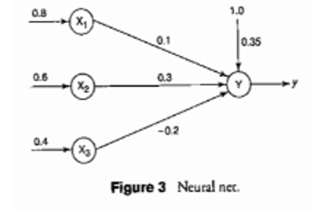
- Implement XOR function using McCulloch-Pitts neuron (consider binary data).
- Explain Feed forward Neural Networks.
- With a suitable example explain how backpropagation works.

Module 2
- Explain the role of drop out in training neural network.
- Explain the importance of validation curve in neural network.
- Explain the role of overfitting, underfitting and training curve in neural network.
- Explain the role of batch normalization in training a neural network.
- Explain with an example how graphs are stored and represented in TensorFlow.
- Discuss how graph representation can accelerate computing models.
- Explain feature and weight visualization in tSNE.
- Explain the ideas of Rank, Shape and Type with an example in the context of a Tensor Data Structure.
- Explain the role of batch normalization in training a neural network and describe how to find out overfitting from training and validation curves.
- How to create deep learning models using keras?
Module 3
- Draw and demonstrate the VGG-16 architecture.
- Sketch the AlexNet architecture and explain its functionalities.
- With a suitable numerical example illustrate convolution operation.
- An input image has been converted into a matrix of size 12 X 12 along with a filter of size 3 X 3 with a Stride of 1. Determine the size of the convoluted matrix.
- Why do we prefer Convolutional Neural networks (CNN) over Artificial Neural networks (ANN) for image data as input?
- What is max pooling in the context of CNN?
- Explain ReLU.
- With a suitable example, illustrate convolution operation.
- Illustrate the working of Lenet.
Module 4
- Explain Recurrent neural networks
- You are given an image data set with 10 classes. Describe how you will use deep learning to build a classifier.
- Describe how LSTM works.
- Explain the problem of vanishing gradients.
- Explain the working of truncated back propagation through time.
- How to solve the vanishing gradient problem with LSTMs.
- Write notes on GRU.
Module 5
- Write a note on auto encoders
- Explain the idea behind cross entropy
- Distinguish between generative and discriminative models
- Explain how a GAN is trained.
- Explain loss function cross entropy.
- What are the challenges faced by GAN.
- Explain Wasserstein loss.
- Briefly describe Discriminative and generative models.
- Write a note on variational auto encoders.
- Explain the importance of GAN Discriminator, GAN Generator and upsampling.

